**CPSC 481 23F Final**

Due time: check canvas

Submission: Submit **ONE ipynb file**. Your file needs to include comments.

Hint: All problems can be solved with a minor variation of your participation/programming assignment code. You can reuse code from past assignments.

Q1 Given maze below

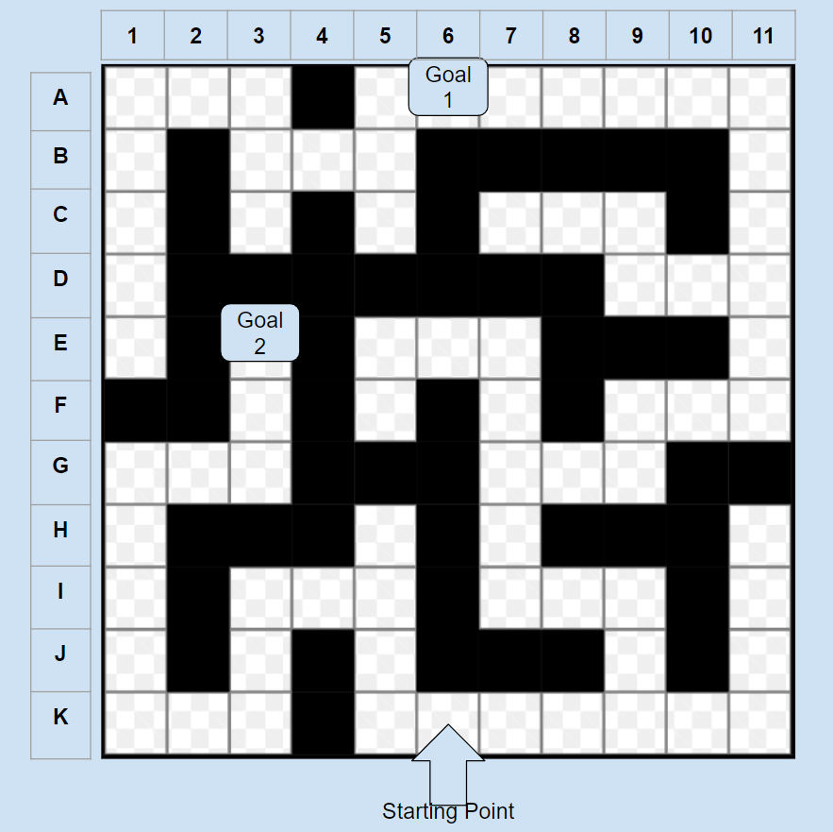

You are required to select a proper algorithm to complete tasks below

1 reach goal 1 from starting point.

2 reach goal 2 from starting point.

Your algorithm needs to use less memory than BFS and guarantees to find the shortest path.

Your output is paths from starting point to goals.

Q2 You are required to find all the valid, but unrepeated states of a tic-tac-toe game. However, in this game, X always goes first, and O second.

Your output is a JSON file that includes all the states and their child state(s).

States must in below form

|  |  |  |
| --- | --- | --- |
| X |  |  |
|  | X |  |
|  |  | O |

Represented as “X---X---O”

Q3 Load mnist digit classification dataset. This can be done easily with keras API. Some other libraries also have it built-in if you decided not to use keras.

For keras, check this link <https://keras.io/api/datasets/mnist/>

This dataset contains numbers in black and white. You may find example drawings of this dataset in the link below.

<https://www.kaggle.com/code/hojjatk/read-mnist-dataset/notebook>

Now, build a model that achieves at least 85% accuracy for image classification tasks.

You are required to split data into 20% testing and 80% training.

Show your model evaluation in submission.

Q4 Load California housing price regression dataset. This can be done easily with keras API. <https://keras.io/api/datasets/california_housing/>

Description of the dataset can be found in this link.

Now, build a model that has predicted values fall within +-15% of the observed value higher than 85% of the time.

You are required to split data into 20% testing and 80% training.

Show your model evaluation in submission.